CSC 170 Lab 7 – CSS for Layout

Due: Tuesday, October 10, 2017

# Step 1: Make a copy of Lab 6

* *After* you’ve completed Lab 6 and got an acceptable grade, make a copy of all the files in it to a new folder named **lab07**
* Change the TITLE in the HTML to reflect the change to “Lab 7…”

# Step 2: Add a layout technique to your webpage

* Your document must use a “container” as demonstrated in a recent lecture. You don’t have to constrain *all* your content (although that’s okay if you do), but you must demonstrate good use of the trick…
* In HTML…  
  <body>  
  <div class="container">  
    
  </div><!--.container-->  
  </body>
* In CSS, create a class named ".container" and apply the appropriate styles to make the content "float" so to speak, in the center of the viewport.
* 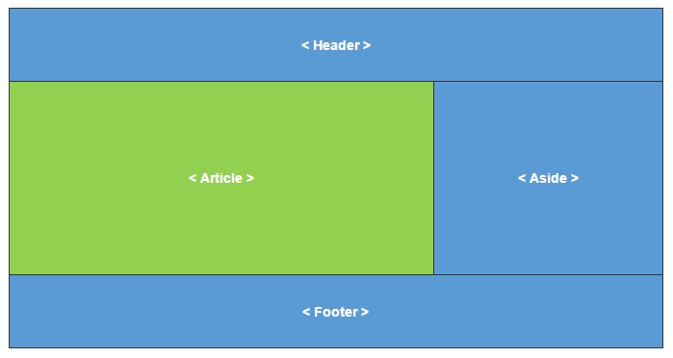Using the CSS **Grid** layout technique, position your HEADER, ARTICLE, ASIDE, and FOOTER elements into a classic "c-clamp" layout.
  + All four structural elements in your webpage must be positioned using GRID properties.
* Do not alter your original HTML document.
  + However, depending on how you setup your content originally in your ARTICLE and ASIDE you may need to move some content around to balance the page layout.[1]
* When you position the content, chances are you’ll need to adjust the box model of the elements that are side-by-side to keep the content readable and generally usable. For example, if the ARTICLE and ASIDE elements were full of text, and then you lay them out side-by-side, the content smashes against the sides like this:   
  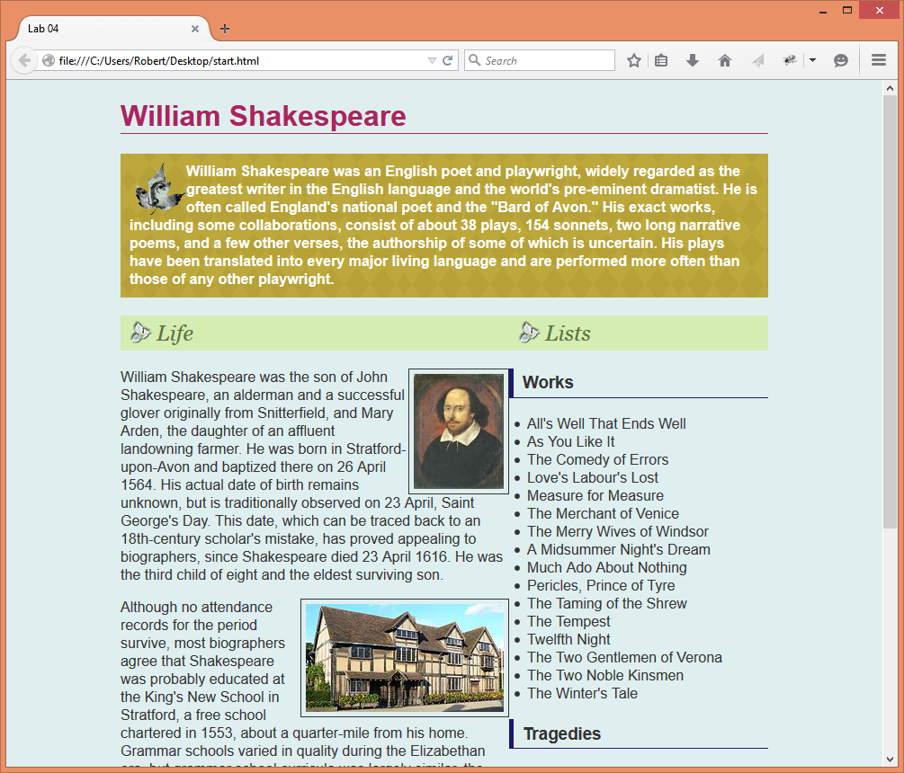

The content needs to be separated by making alterations to the box model of the ARTICLE and/or ASIDE

Alter the box model of the elements (in this case, that’ll be the ARTICLE and/or ASIDE) by adding margin and/or padding to them as demonstrated in the last lecture, OR by using the appropriate GRID property to apply a "gutter."

# Step 3: Upload your work

When you are done with your webpage, close everything and use an FTP tool (like *WinSCP*) to access your account on **urcsc170.org** and upload your files:

* In a web browser (any), go to this address to check your handiwork:   
  **www.urcsc170.org/*accountname*/lab07/start.html**  
  (where “*accountname*” is your account name)

# Report your work

Remember: Use the W3C HTML validator (**validator.w3.org**) AND the W3C CSS validator (**http://jigsaw.w3.org/css-validator**) to check your work before you report it!

* In our Blackboard section, in Lab 7, post a link to your webpage to receive credit for this Lab.

1. Normally you would never do that, but for these lab assignments it's okay - just for demonstration purposes.